ENEE417 Final Report: LED Driver

Peter Russo
12/18/07
Introduction

This circuit is intended to transmit radio frequency (RF) data using an infrared (IR) light emitting diode (LED) when given an RF input voltage. The cutoff frequency must be at least several megahertz, in order to transmit a 1 MHz square wave. There are two different transmitter designs. The FM transmitter provides an input voltage to the LED driver with a swing from zero to nine volts. The PWM transmitter outputs a square wave with a -9V to +9V swing. A single-transistor amplifier drives the LED in each case.

Parts Needed

(2) LN77L IR LEDs
(2) 2n3904 npn transistors
(2) 26.8kΩ resistors (optional)
(1) 120Ω resistor
(1) 60Ω resistor
(2) 1kΩ resistors (to step down input voltage and eliminate ringing)

Operating Principle:

Two different LED drivers were built, tailored to match the different input voltages. The PWM driver requires a positive and negative voltage supply whereas the FM driver only needs a positive supply. Neither circuit is capacitively coupled. When the input voltage swings to zero, the current is entirely cut off. This choice was made to reduce power consumption. There is no offset bias current, so the LED swings from entirely off to entirely on. However, this choice reduces the quality of the signal, as significant distortion can occur when the transistor enters saturation mode.
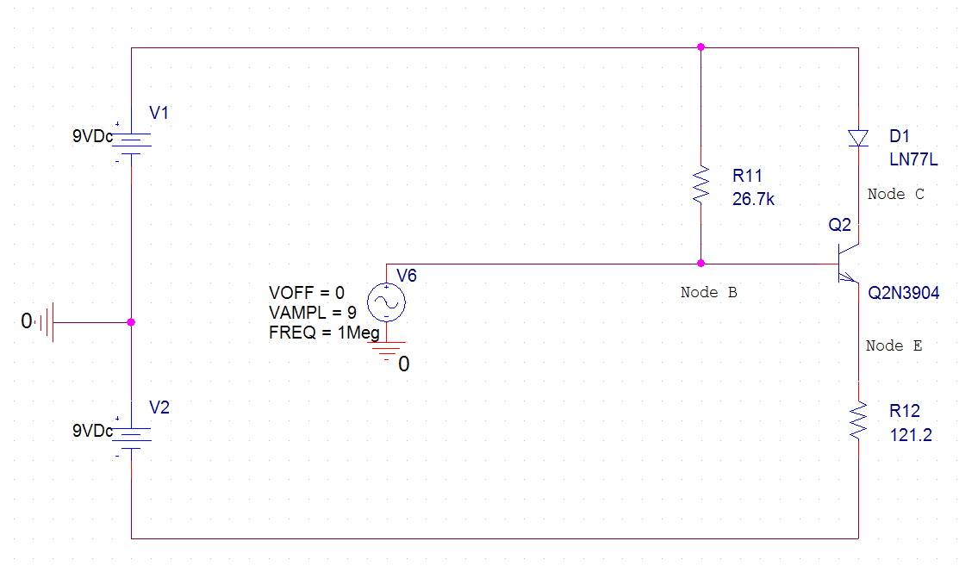
Figure 1: PWM circuit schematic, as built

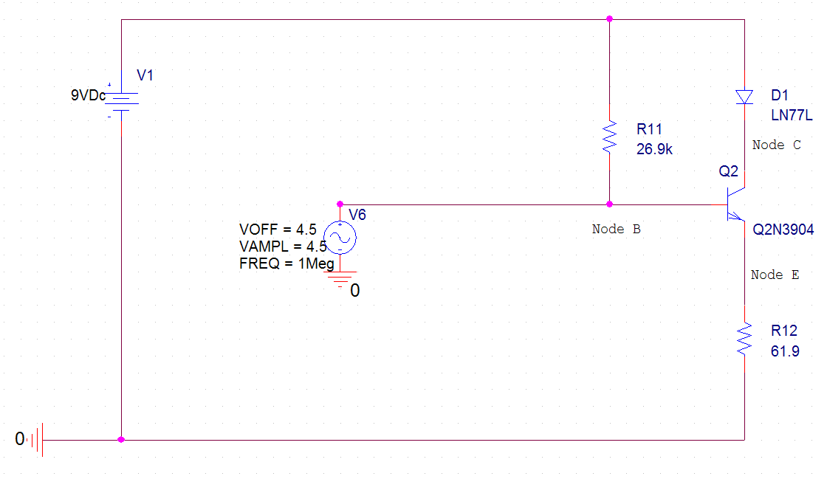
Figure 2: FM circuit, as built

It is useful to view the LED driver as a common collector amplifier with a load at the collector. You can get a good approximation of the amplifier’s transconductance by assuming unity voltage gain from the base to the emitter. The swing of the emitter current is then given by:

Ie = Ve/Re = Vb/Re = Vin/Re

But we are interested in the current to the LED:

Iout = Ic = αIe = αVin/Re
Iout/Vin = α/Re [Note: Re is denoted R12 in figures 1 & 2]

The transconductance will not be quite this high, as voltage gain is less than unity. Both LED drivers are designed so that Iout is 100 mA peak to peak, which is about 70 mA RMS.

Note that R11 is not necessary. It is included for debugging purposes – if the input voltage is left open, R11 biases the transistor to sink about 50 mA from the diode – a bright signal that can be used to verify the functionality of either the LED driver or the photodiode. Under normal operation, it does not draw extra power, and it does not decrease the input impedance by much, as R11 is roughly five times as resistive as Zin.

Simulation

PSPICE does not include the LN77L in its library. In order to simulate the turn-on voltage of the LN77L, two 2n4148s were placed in series, to get a cumulative turn on voltage of approximately 1.4V. The circuits used for simulation are shown in figures 3 and 4.

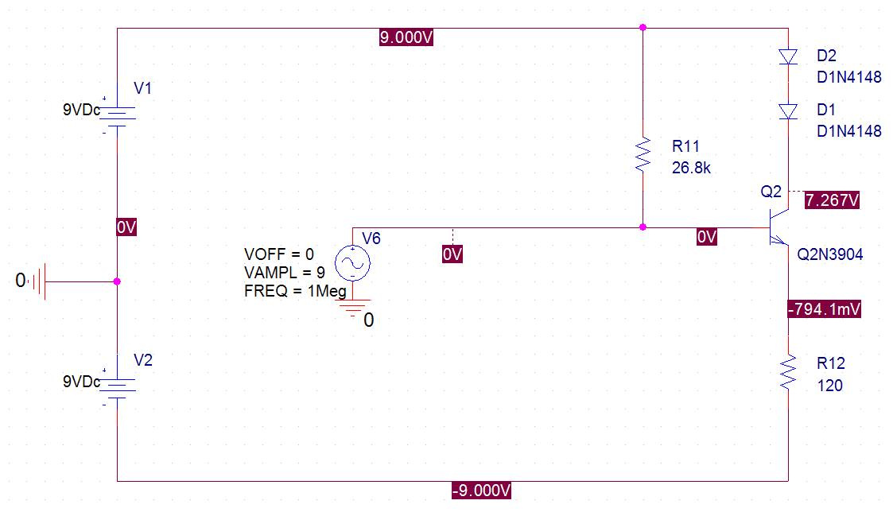
Figure 3: PWM Simulation Circuit

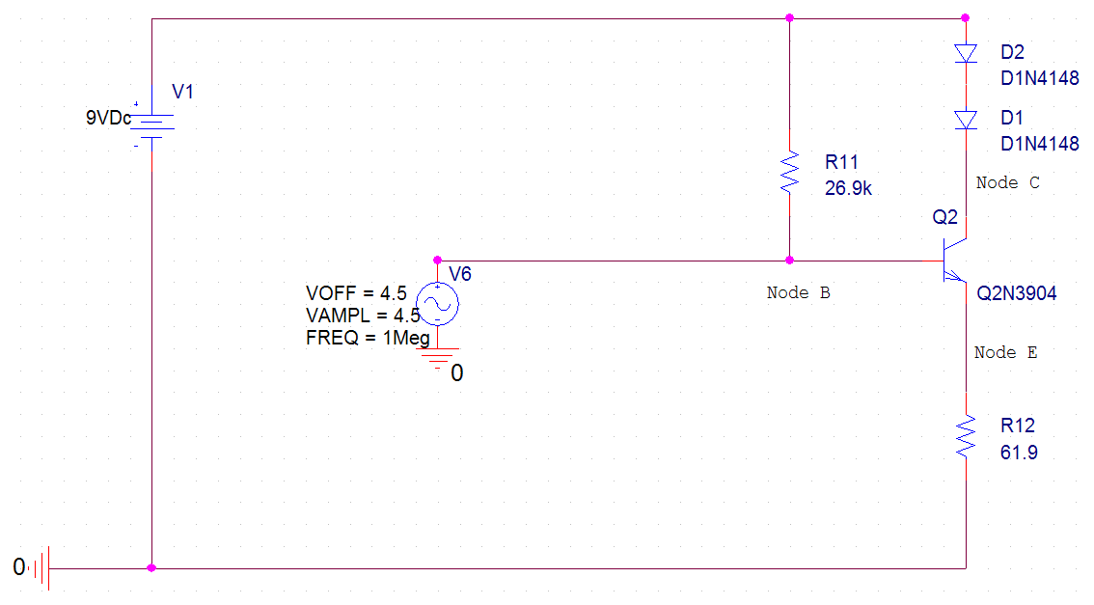
Figure 4: FM Simulation Circuit

Figures 5 and 6 show the simulated frequency response of current and voltage at the diode in the FM driver. Note the high frequency abnormalities in the response.

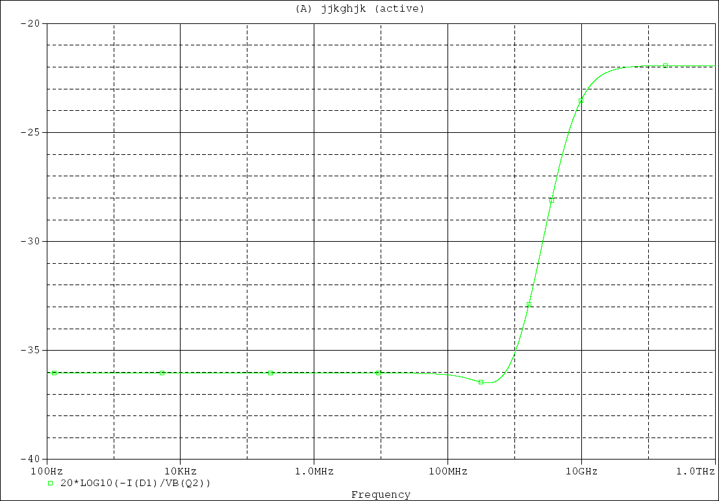
Figure 5: Frequency response of current through diode in FM driver

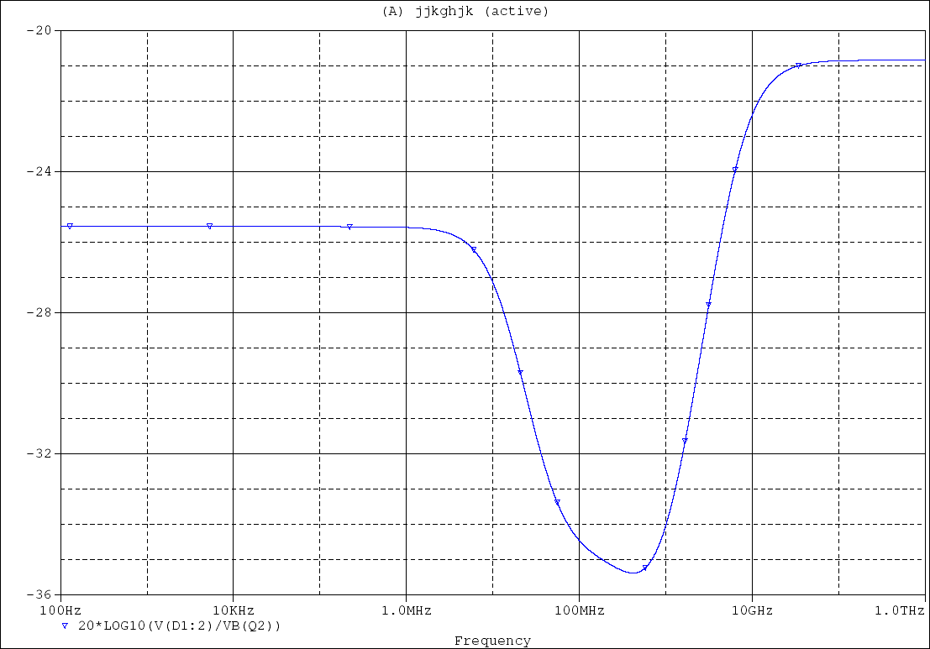
Figure 6: Frequency response of voltage at diode (node C) in FM driver

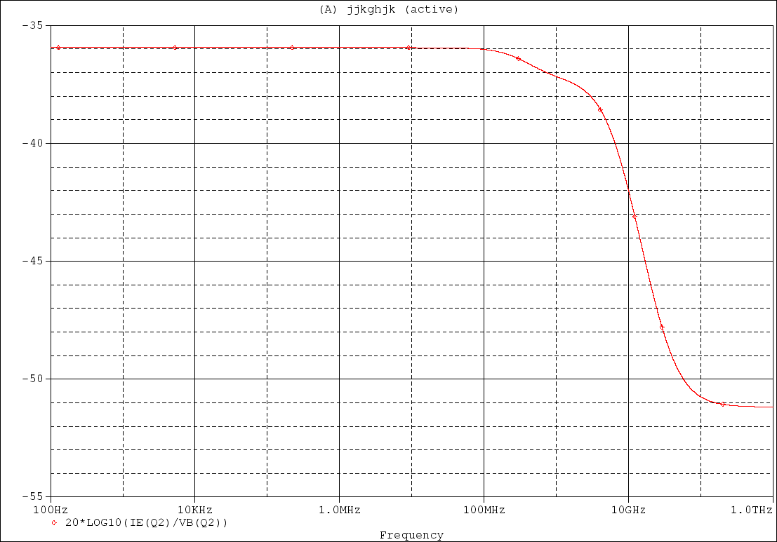
Figure 7: Frequency response of current at node E for FM LED driver

The above simulations are only useful to qualitatively describe the shape of the frequency response. LEDs are slower than diodes. The rolloff frequencies cannot be expected to match.
To understand the high frequency abnormalities, we must look at a sample signal. Figures 8 and 9 show the simulated current and voltage at the diode with a 9V peak to peak input sine wave at 1 MHz. Figure 8 shows that for a 0 to 9 V input signal, the emitter voltage “pushes” the collector voltage higher, as the minimum emitter-collector voltage that can be maintained in saturation mode is about 0.2V. This aberration in the signal appears to cause some ringing at the collector after the emitter voltage drops. As the input frequency increases, the emitter will push the collector voltage high faster. The stimulus will appear more and more like a delta function as frequency is increased, causing greater ringing at high frequencies. Thus, it appears that the gain seen at high frequencies is due to high frequency ringing in the circuit.

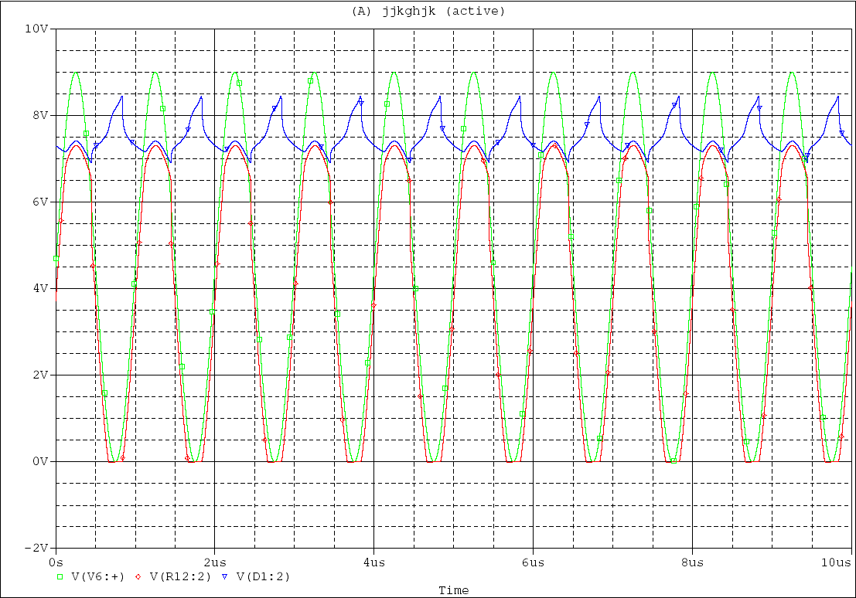
Figure 8: Simulated voltages at node B (input, green), node E (red) and node C (blue) for FM driver
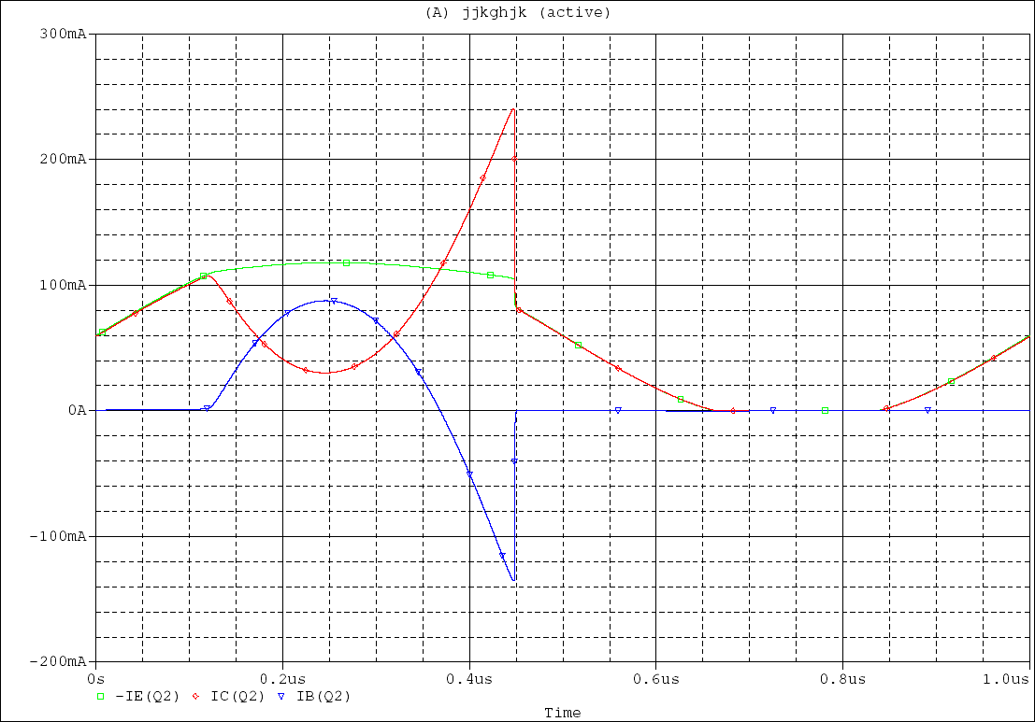
Figure 9: Simulated currents at node B (blue) node E (green) and node C (red) for FM driver

We can fix the ringing problem by keeping the transistor out of saturation mode. To do so, we step down the input voltage by inserting a 1k resistor in series with the input to the circuit, as shown for the PWM driver in figure 10.

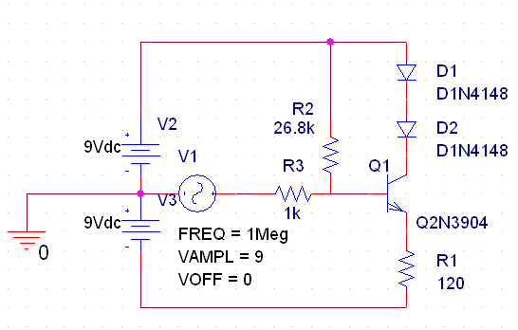
Figure 10: PWM driver with step-down series resistor

The 1k resistor creates a voltage divider between itself and the circuit, which has an input impedance of about 6kOhms. Simulations, as shown in figures 11 and 12, demonstrate that this resistive divider eliminates ringing.

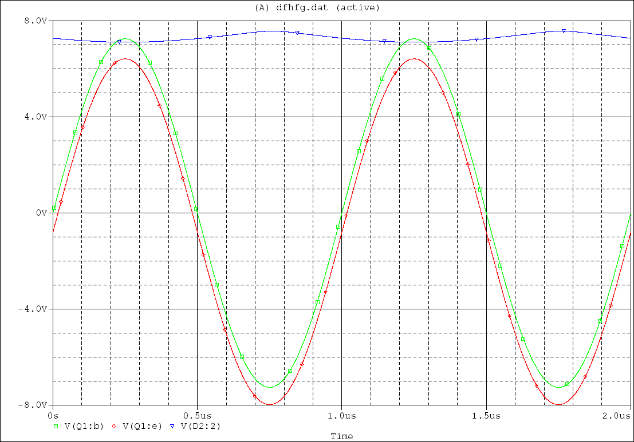
Figure 11: Base voltage (green), emitter voltage (green), and collector voltage (blue) for PWM LED driver with 1k series resistor at input. Input is an 18 V P-P 1 MHz sine wave.

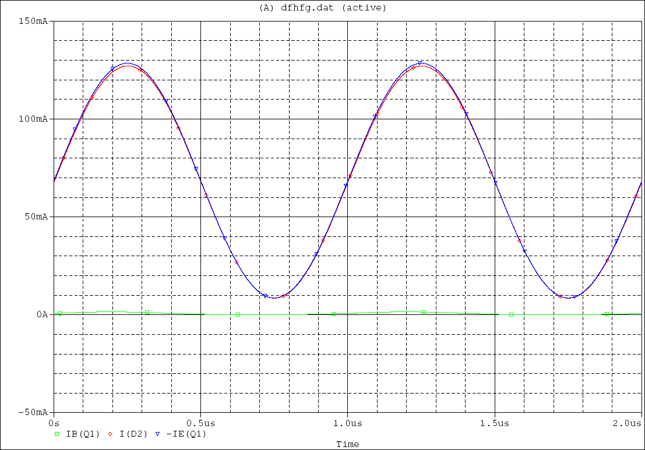
Figure 12: Base current (green), emitter current (blue), and collector current (red) for PWM LED driver with 1k series resistor at input. Input is an 18 V P-P 1MHz sine wave.

Simulations for the PWM circuits are similar to those for the FM circuits. The data is presented below.
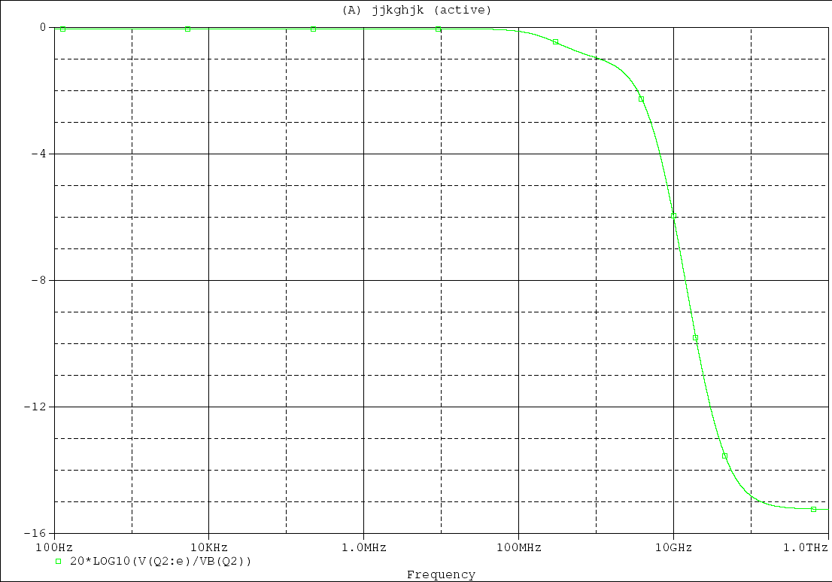
Figure 13: Frequency response of voltage at node E for PWM circuit.
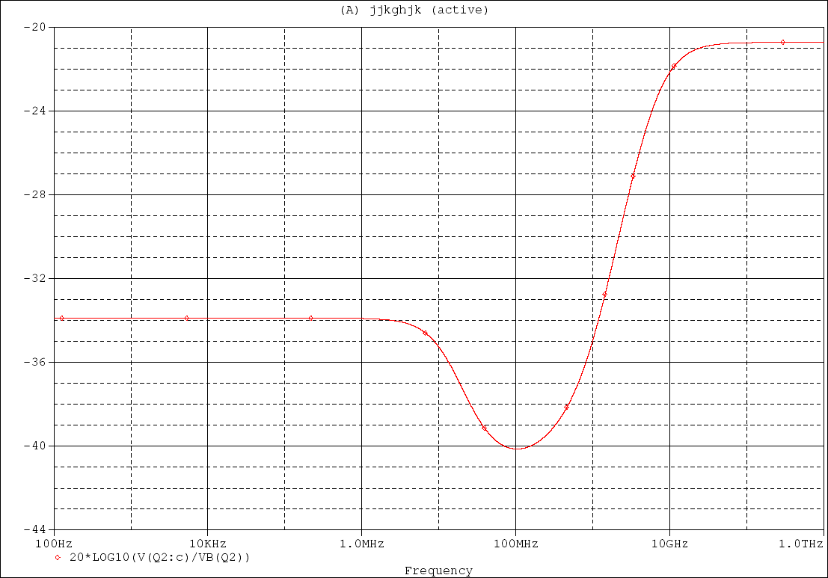
Figure 14: Frequency response of voltage at diode (node C) for PWM driver

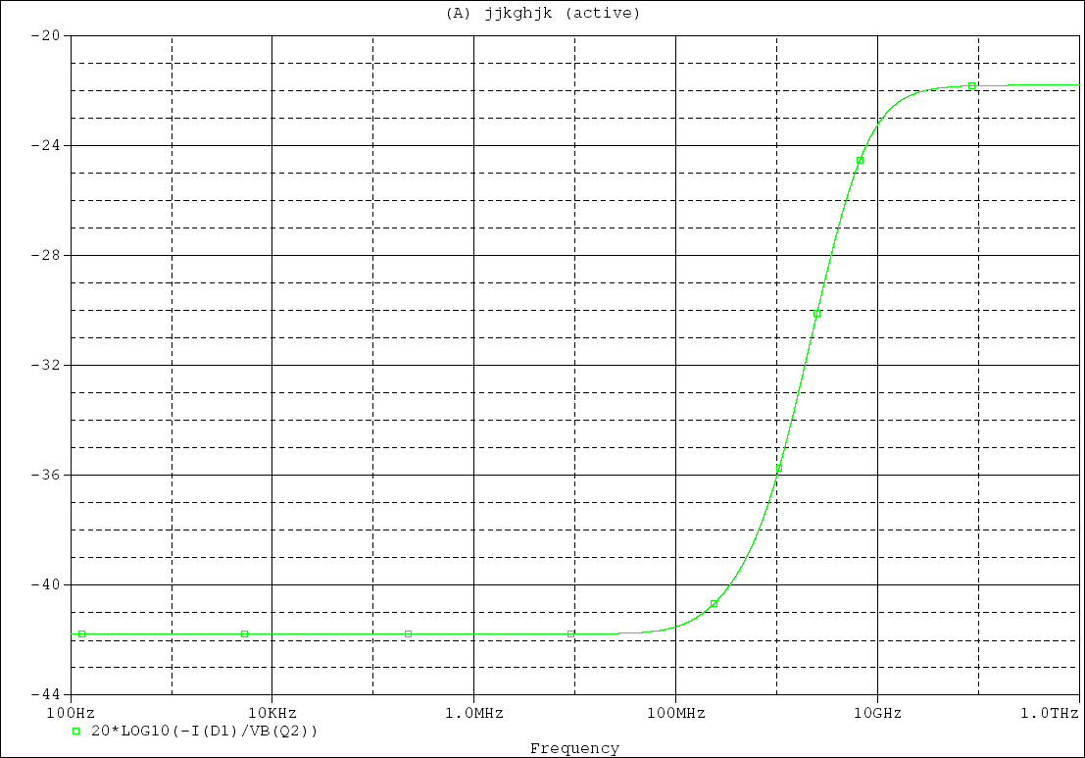
Figure 15: Frequency response of current at diode (node C) for PWM driver

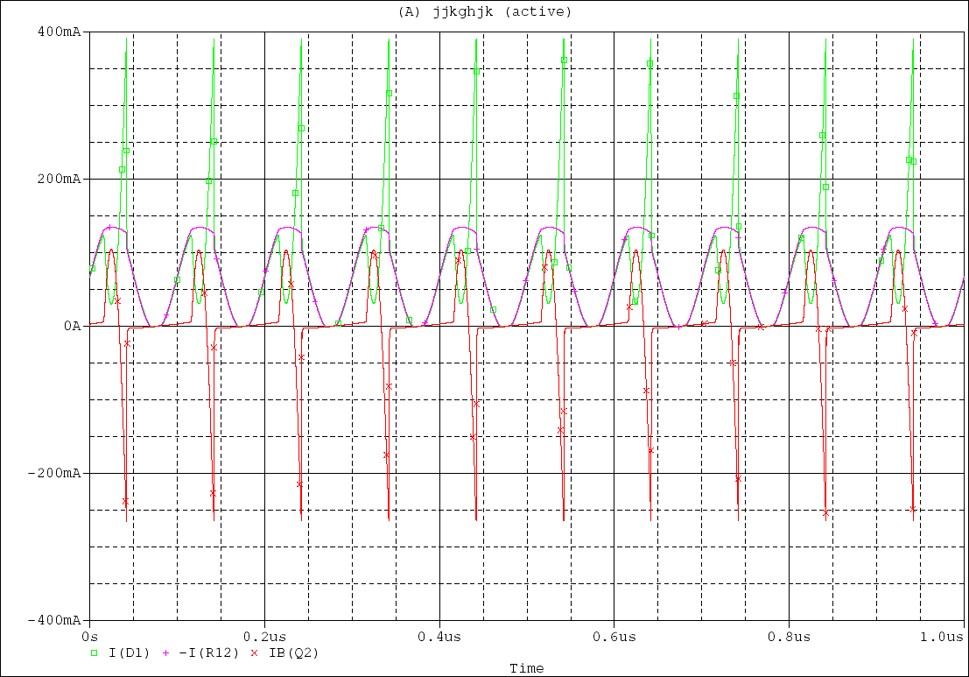
Figure 16: Currents as a function of time at node E (pink), node B (red) and node C (green) for a 1 MHz sine wave input, PWM driver

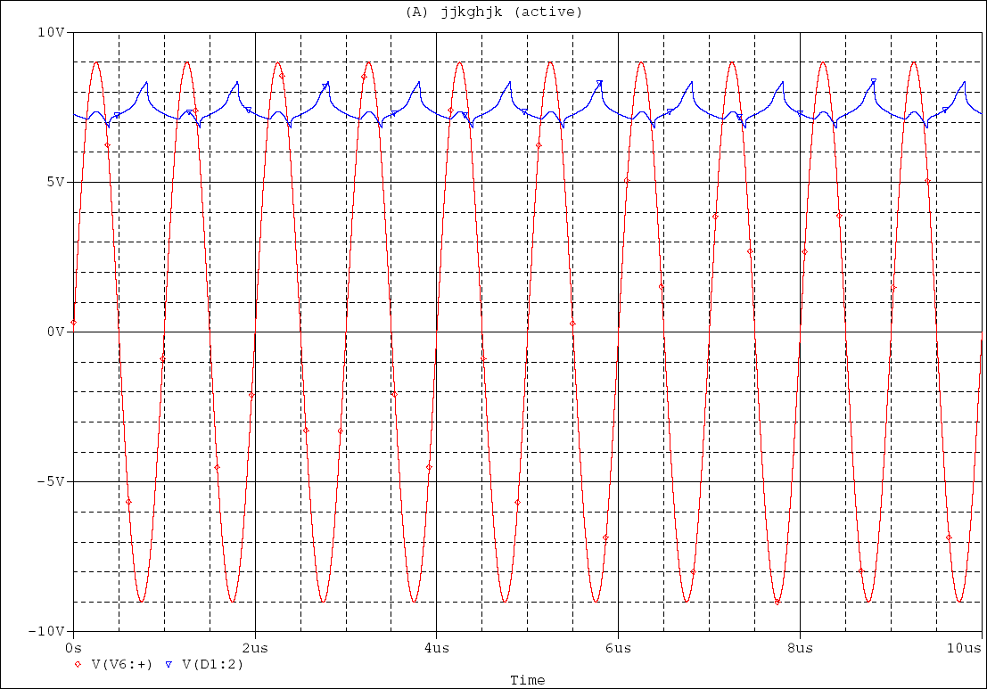
Figure 17: Voltage as a function of time at node B (red) and node C (blue) for PWM driver with a 1 MHz sine wave input

PCB Schematic:

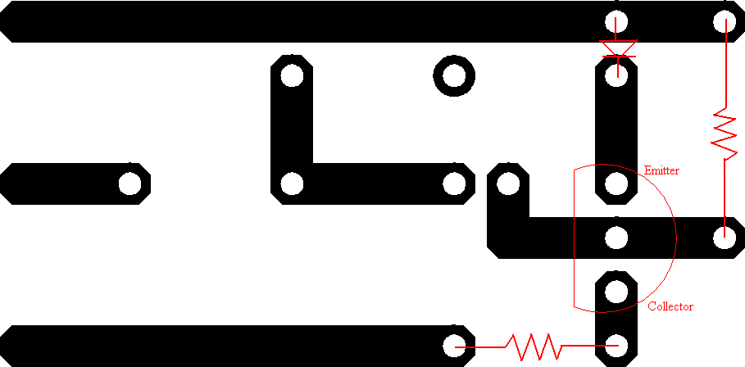
Figure 18: Etch mask for PCB. Black areas are filled with copper in the completed PCB. Red marks are just for annotation.

The PCB included extra leads to add an arbitrary resistive divider network and coupling capacitor, in case of design changes.

Measured Data:

Figures 19 and 20 show the measured input impedances (magnitude) as a function of frequency for the PWM and FM drivers. Figures 21 and 22 show the test circuits used to measure the input impedance.

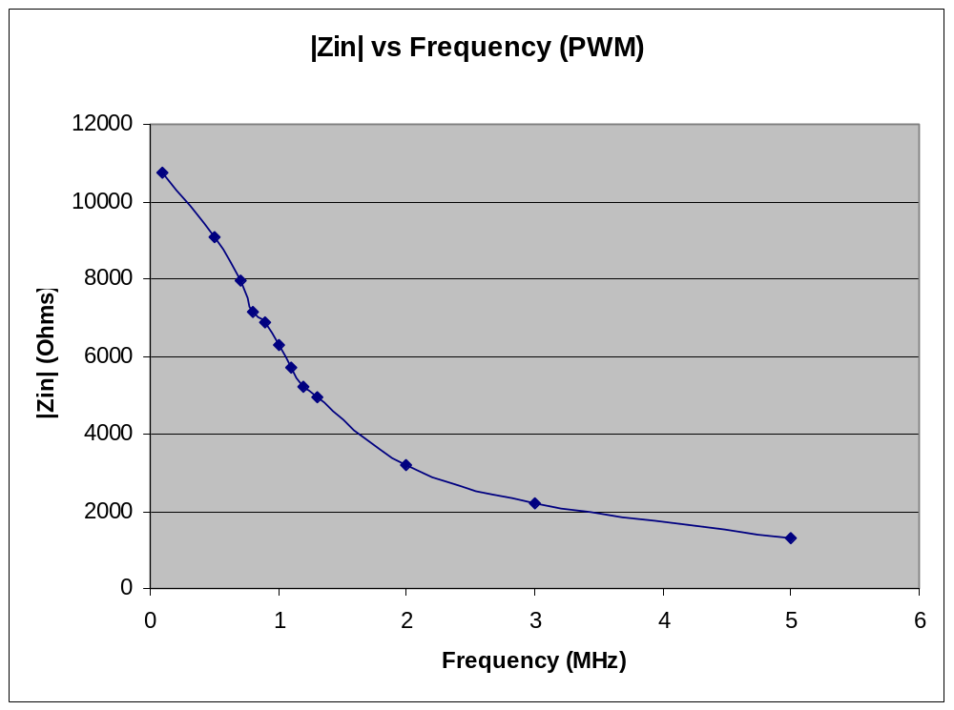
Figure 19: Input impedance as a function of frequency for the PWM driver

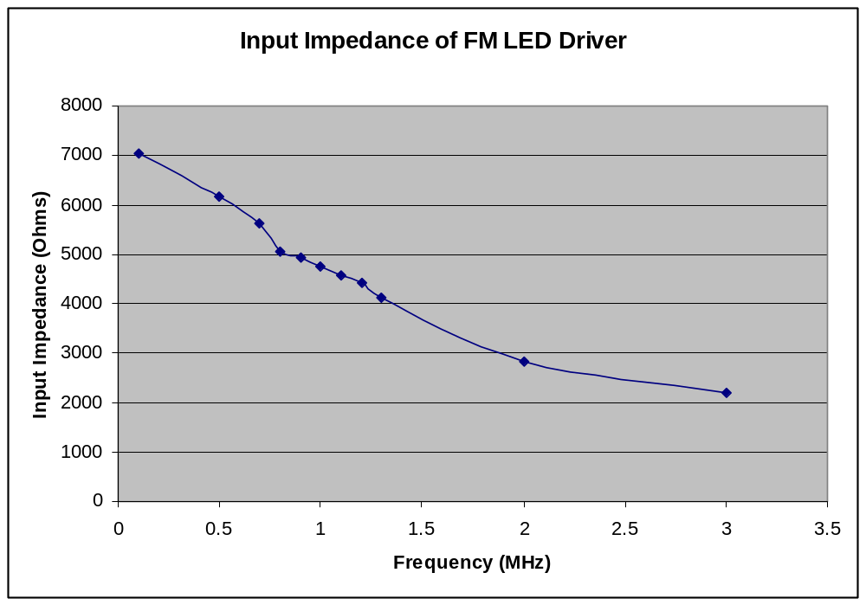
Figure 20: Input impedance of FM driver as a function of frequency

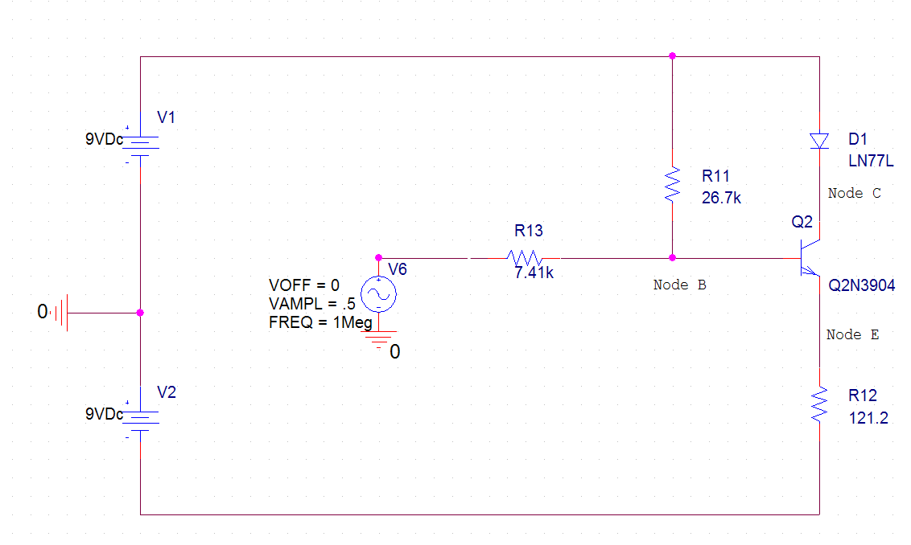
Figure 21: Test circuit used to evaluate PWM input impedance. Voltages were measured at input and node B.

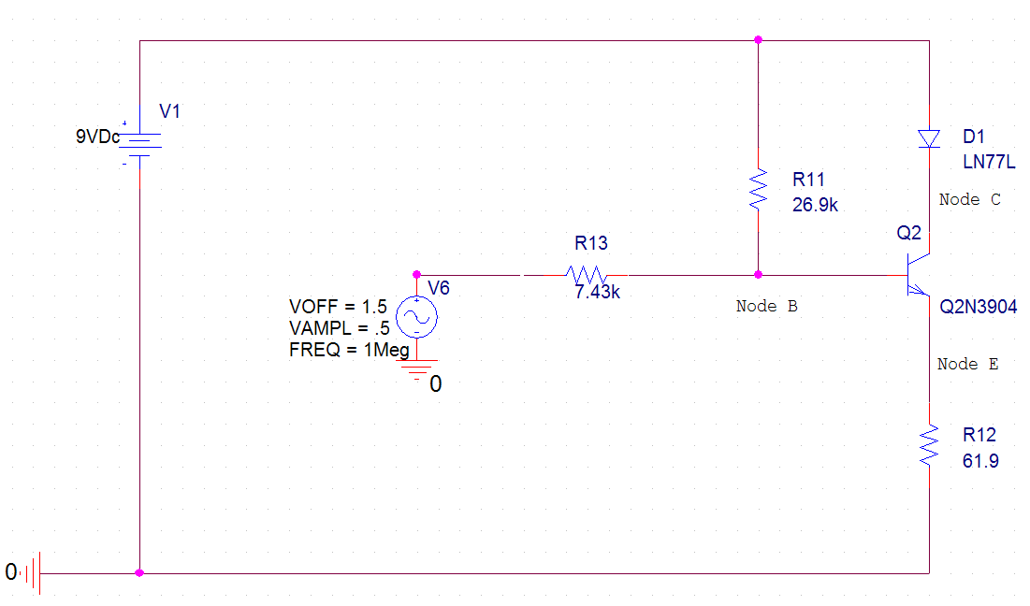
Figure 22: Test circuit used to evaluate FM input impedance. Voltages were measured at input and node B.

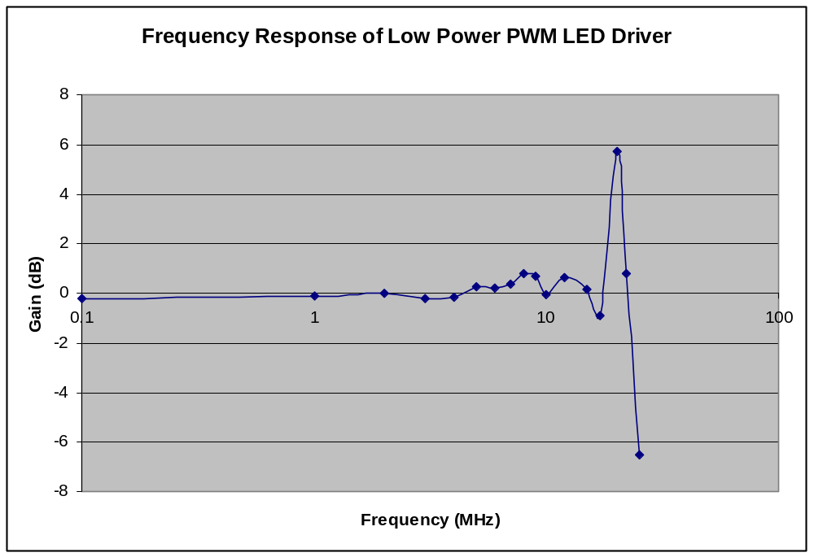
Figure 23: Measured frequency response of PWM driver at node E.

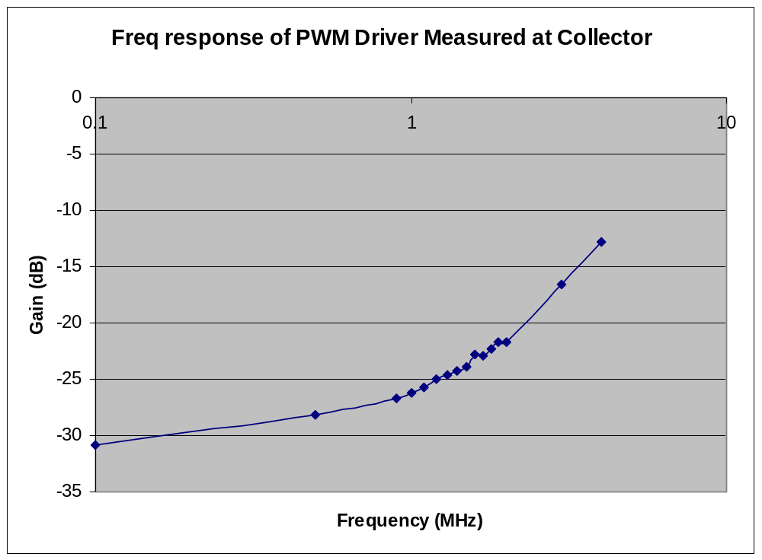
Figure 24: Measured frequency response of PWM driver at node C.

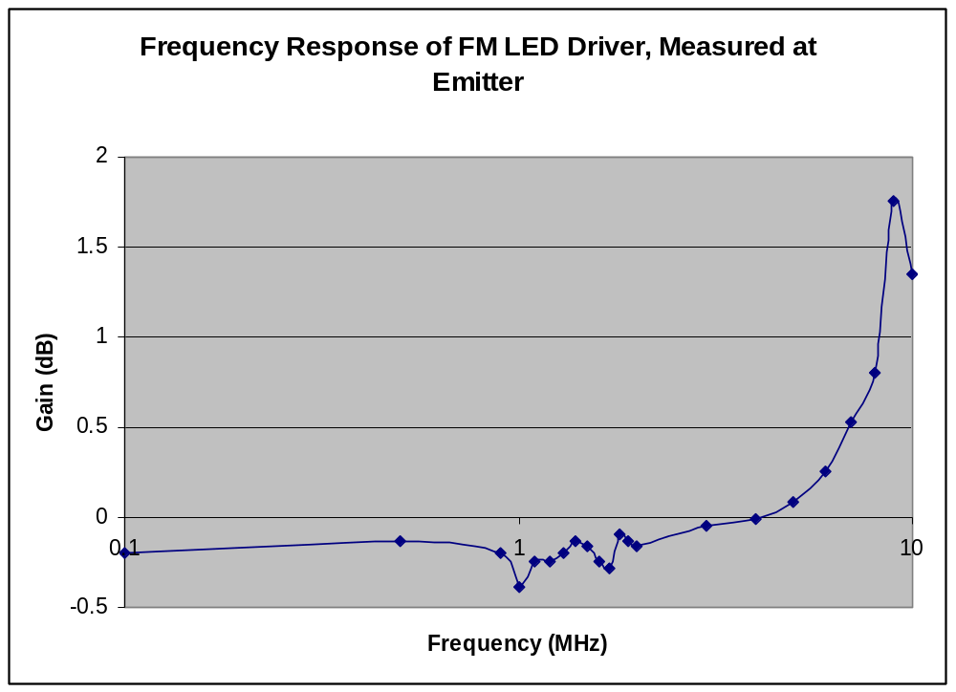
Figure 25: Measured frequency response of FM driver at node E

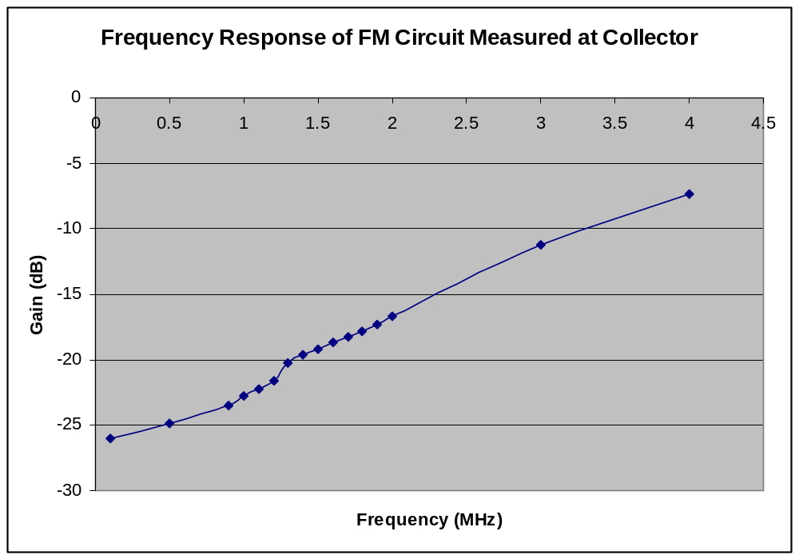
Figure 26: Measured frequency response of FM driver at node C.

The frequency responses shown in figures 23, 24, 25, and 26 appear to be non-physical, because the gain increases with frequency. However, these effects are due to ringing, as demonstrated by simulation. Figures 27 and 28 show some sample data that capture the ringing effect.

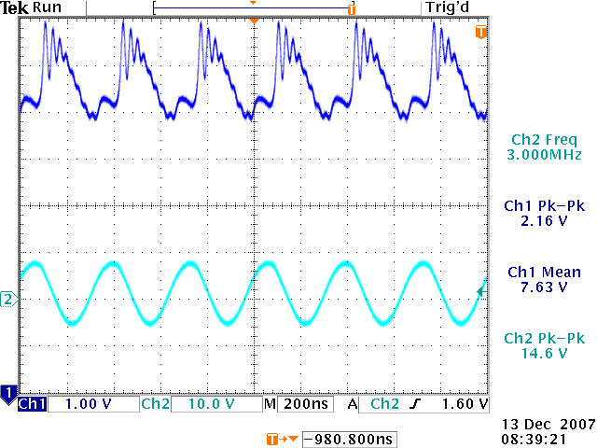
Figure 27: PWM LED driver with -9 to 9 V input sine wave at 3 MHz. The dark blue trace is the collector voltage. The light blue trace is the input (base) voltage.

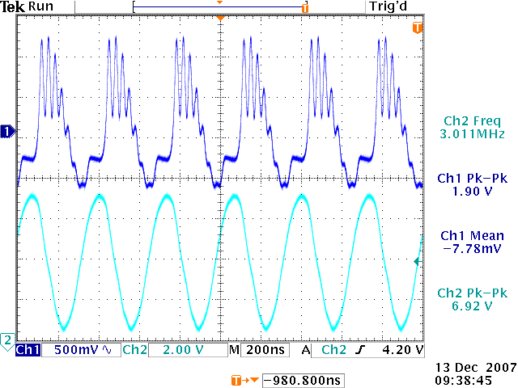
Figure 28: FM LED driver with 0 to 9 V input sine wave at 3 MHz. The dark blue trace is the collector voltage. The light blue trace is the input (base) voltage.

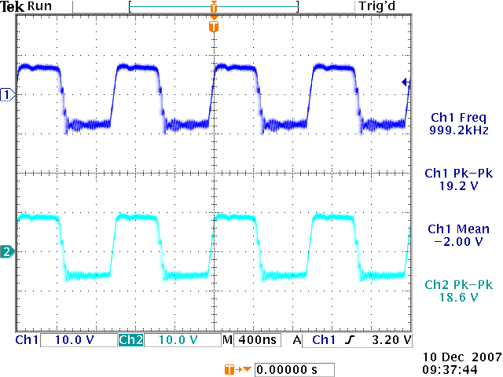
Figure 29: Output of PWM driver (measured at emitter, channel 2) when hooked up to PWM transmitter. Channel 1 is the output of the PWM transmitter.
As figure 29 shows, despite problems with ringing, the LED driver is still capable of properly transmitting encoded audio data. Nonetheless, transmission quality can be improved by eliminating ringing.

To correct the ringing, a circuit with a 1k resistor in series with the input was constructed for just the FM case (due to time constraints). Figures 30 and 31 show some sample traces. Figures 32 and 33 show the frequency response of this circuit, as measured at emitter and collector.

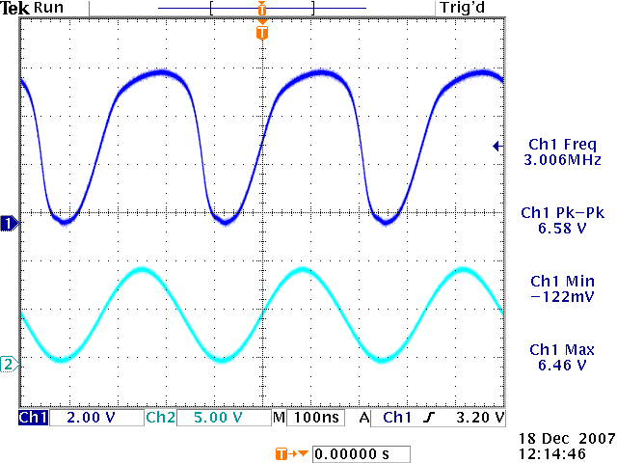
Figure 30: Voltage measured at emitter for FM driver with 1k series resistor under an applied 3 MHz, 0V to 9V input sine wave. Note that no ringing is apparent.

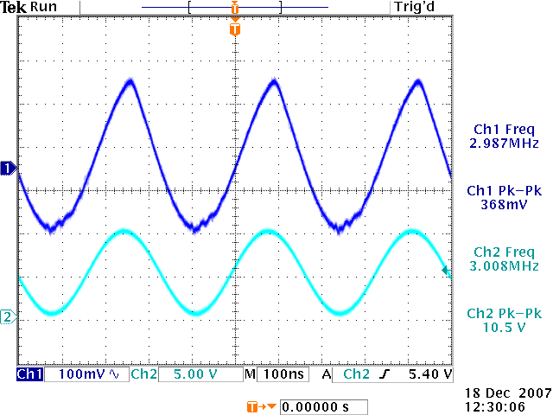
Figure 31: Voltage measured at collector for FM driver with 1k series resistor under an applied 3 MHz, 0V to 9V input sine wave. Note that little ringing is apparent.

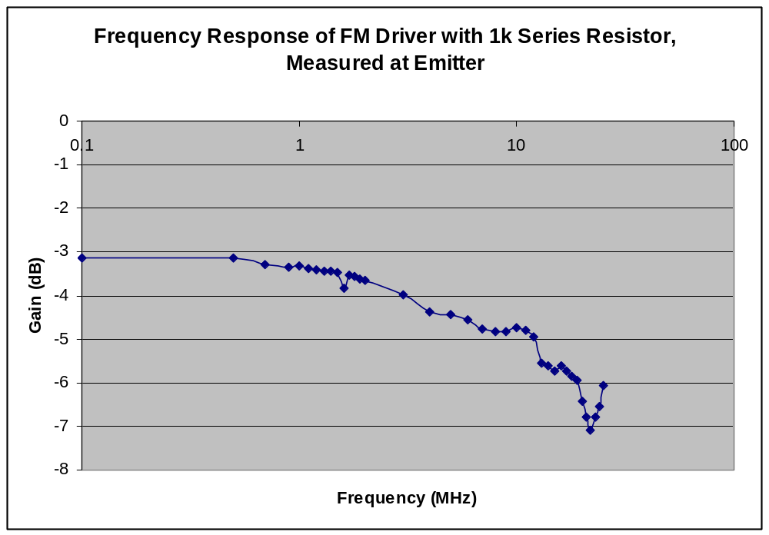
Figure 32: Frequency response of FM driver with 1k resistor in series with input, as measured at emitter.

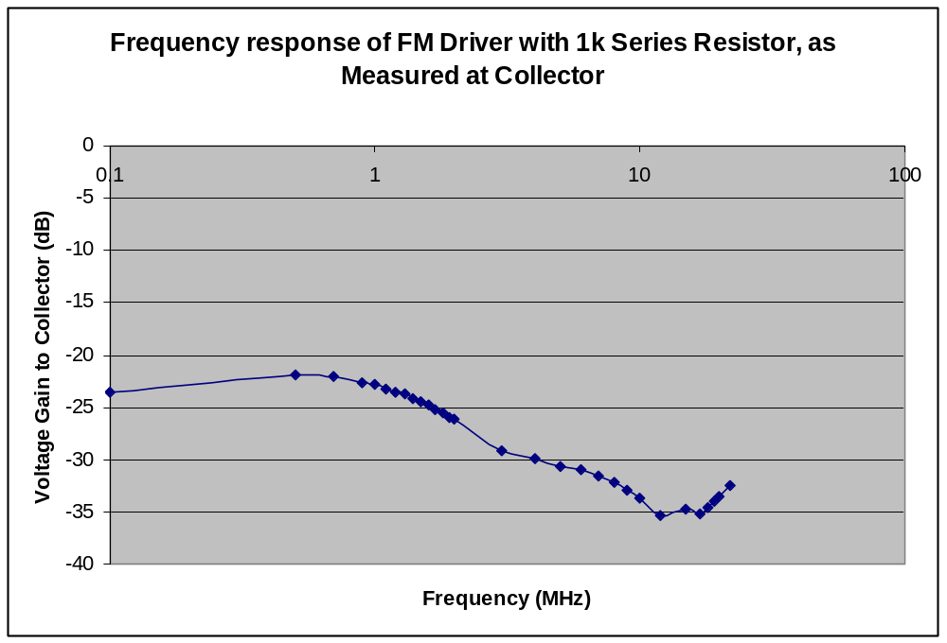
Figure 33: Frequency response of FM driver with 1k resistor in series with input, as measured at collector.

Conclusions:

The LED drivers are well-suited to transmit encoded audio data with a center frequency of about 1 MHz. The input impedance is about 5 kOhms for the FM case, and about 6 kOhms for the PWM case. The gain begins to roll off at about 1 MHz, with a -3 dB point of about 3 MHz, as shown by measurements taken at the collector for the FM transmitter with a 1 kOhm resistor in series with the input signal. Therefore, the circuit is capable of adequately representing a 1 MHz square wave.
The circuit was demonstrated to be suitable for transmitting 1 MHz encoded signals without modifications to the circuit to eliminate ringing. With the modifications, transmission quality should be significantly enhanced.
Appendix


