Audio Frequency Amplifier
Andradige Silva ENEE417

- Introduction
The circuit is intended to amplify the sound signal sent from FM and the PWM circuits. This circuit uses two BJTs configured as class B push-pull amplifier. This is a simple circuit to make and it is capable of producing about 4 Watts of power with an 8Ω speaker.

- Parts Used
2 - LM741 op-amps
1 - 1KΩ resistors
1 - 50kΩ variable resistor
1 - 20µF capacitor
1 - 8Ω Speaker
1 - MJL3281A NPN BJT
1 - MJL1302A PNP BJT

- Operating Principles of the circuit
This circuit in figure 1 consists of 2 stages. The first stage is the preamp stage where the voltage is amplified. The second stage is the push-pull amplifier that amplifies the current.
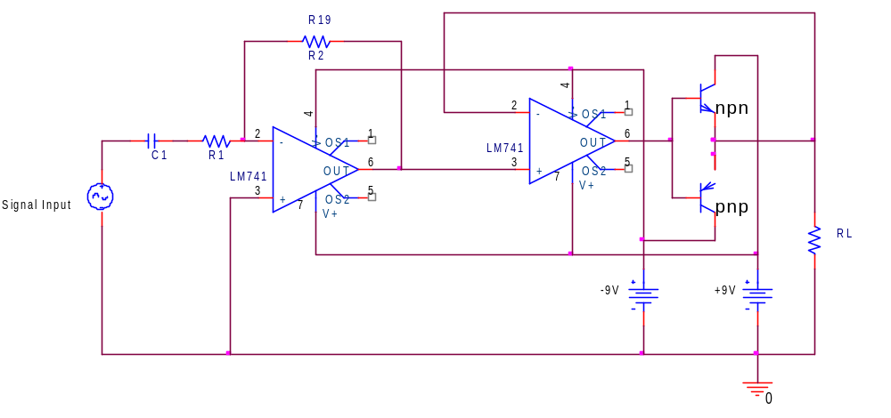
Figure 1. The complete amplifier circuit

Pre-amp stage:
The input is fed into the LM741 op-amp through C1 20µF capacitor. The capacitor is used to remove any DC offset. The op-amp is setup in inverting configuration. The voltage gain is controlled by R1 and R2. I have used a 1kΩ for R1 and a 50kΩ variable resistor for R2. R2 is used as the volume controller. The input impedance of this circuit is about 10KΩ. The input impedance is measured by placing a 1K resistor in series with the input signal and then measuring the drop in the voltage. Then the input current is change in voltage divided by the 1kΩ. The resulting input impedance is the voltage after the resistor divided by input current.

Push-pull amplifier stage:
The push-pull amplifier consists of npn and pnp BJT transistors and an LM741 op-amp. The output from pre-amp is fed into another LM741 op-amp and the op-amp’s output is fed into base of the two BJTs. When the input signal is positive, npn has a positive voltage at the emitter and current flows through the load (speaker) to ground. This keeps the pnp off. When the input signal is negative, pnp has a negative
voltage at the emitter and current flows through the load (speaker) to ground. This keeps the npn off.

Due to the transfer characteristics of BJT’s there is crossover-distortion. This is because the BJT’s need a certain biasing voltage to turn on (about +/- 0.7V). One way to reduce crossover-distortion is by having a high gain op-amp in negative feedback arrangement. This reduces the +/- 0.7V dead band by +/- 0.7/A₀, where A₀ is the dc gain of the op amp. (Sedra, 1240).
Figure 2 shows just the feedback mechanism of this circuit. The following derivations will better explain how the crossover distortion is reduced.
I) (V_{In} – V_{out})A_{o} = V_{x} (The resulting output gain of an op-amp)

II) V_{x} .7 = V_{o} (The .7 drop due to BJT’s)
III) V_{x} = V_{o} .7

IV) (V_{In} – V_{out})A_{o} = V_{o} .7 (Plug V_{x} into eqn. I)
V) V_{In} – V_{out} = (V_{o} .7)/ A_{o} (Solve for V_{out})
VI) V_{out} (1 + 1/ A_{o}) = V_{In} .7 (Since 1/ A_{o}
Eqn VI can be simplified to:
V_{out} V_{In} 0.7/A_{o}

Since the gain is high the op-amp keeps V_{out} V_{In} and results in reduced crossover distortion.
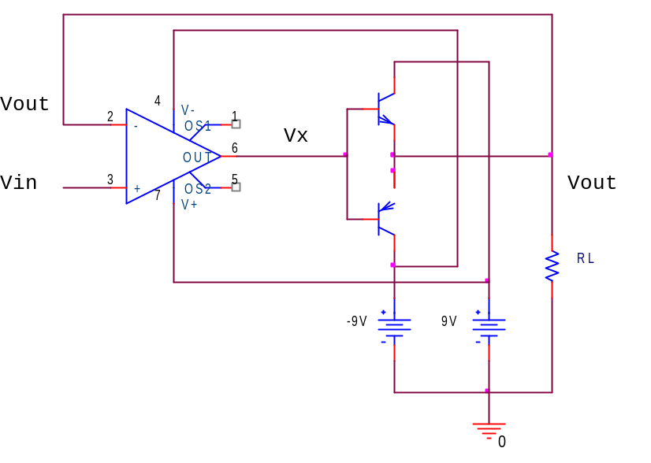
Figure 2. Feedback mechanism

- PSPICE Simulations
The input output characteristics
R1 is set to 1kΩ and R2 is set to 6kΩ for a voltage gain of 6.

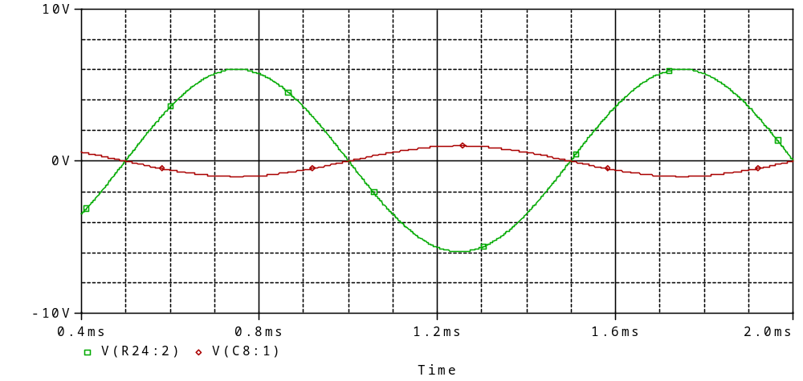
Figure 3. Input (Red) 1V & Output (Green) 6.04V at 1kHz
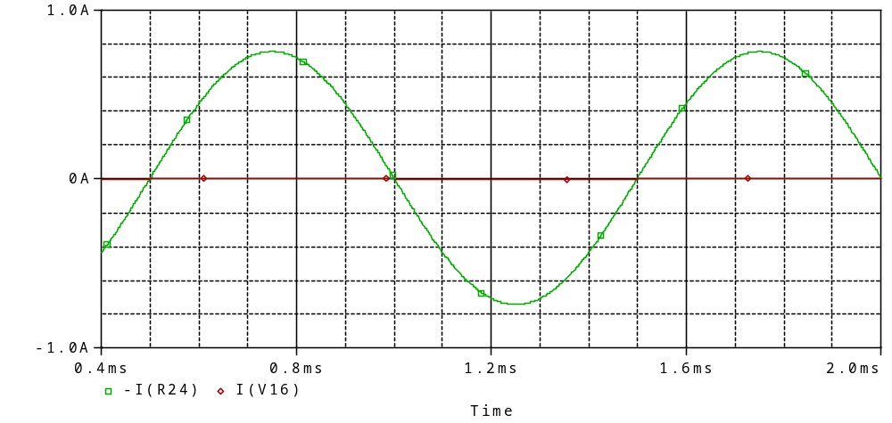
Figure 4. Input (Red) 755mA & Output (Green) 1mA at 1kHz

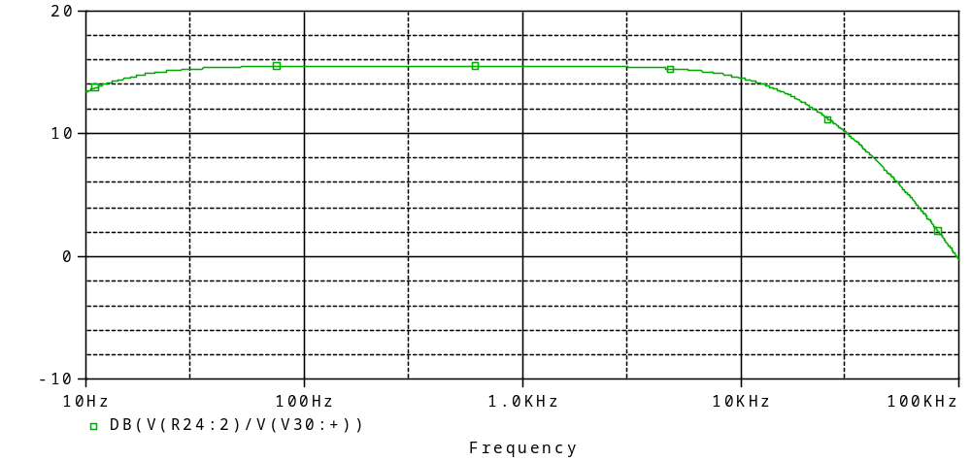
Figure 5. Final Gain

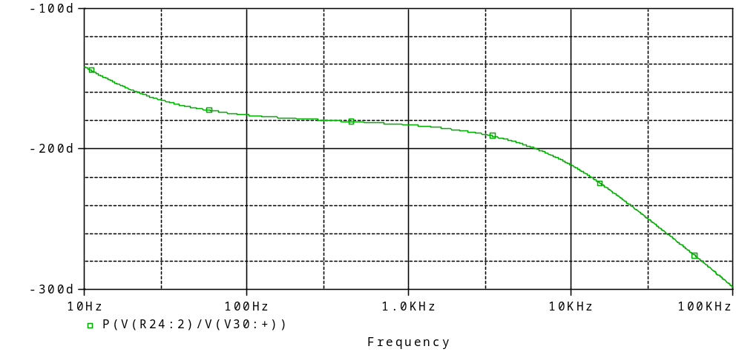
Figure 6. Output phase

For the PSPICE data taken below, the 8Ω load resistor is replaced with a better speaker model shown in figure 6.

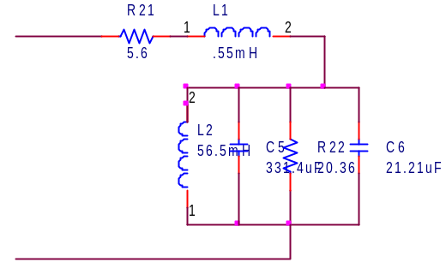
Figure 7. Speaker model
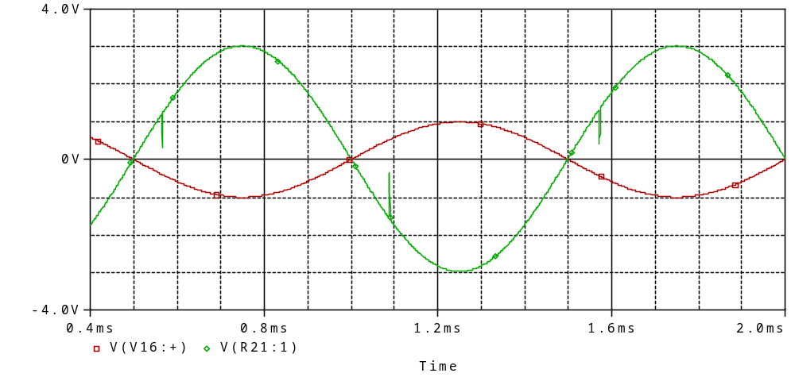
Figure 8. Input (Red) 1V & Output (Green) 3V at 1kHz

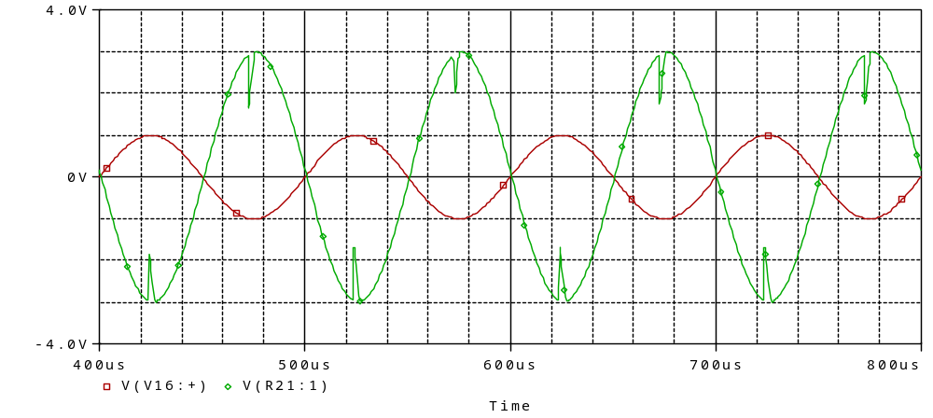
Figure 9. Input (Red) 1V & Output (Green) 3V at 10kHz

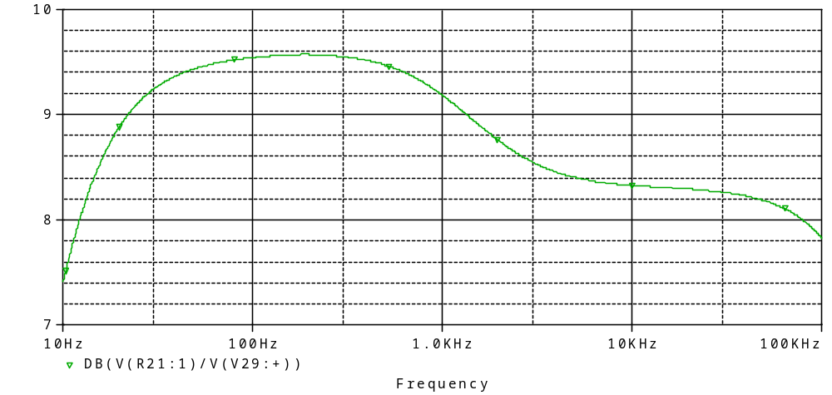
Figure 10. Gain with better speaker model

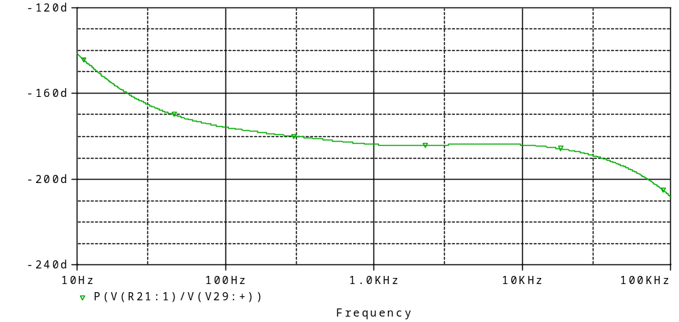
Figure 11. Phase with better speaker model

- Data taken
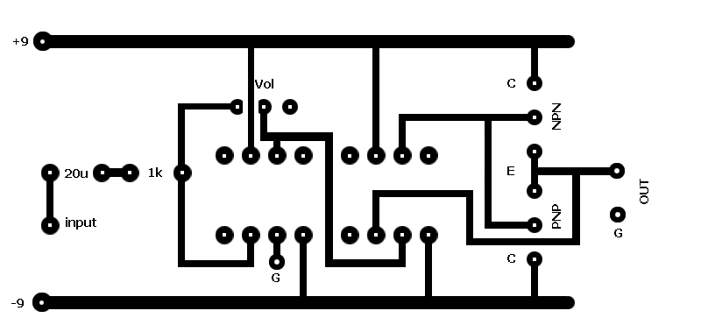
Figure 12. Printed circuit board
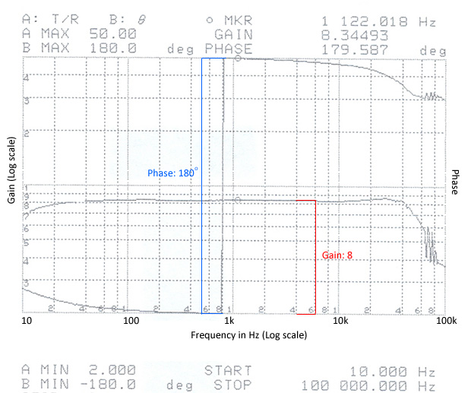
Figure 13. Gain and phase of the circuit
The gain is set to 8 by R2 and the gain starts to drop after 50kHz. The phase is 180º due to inverter op-amp configuration.
For the data below the gain is set to 10 V/V at 100Hz frequency.
Channel 1: Output
Channel 2: Input
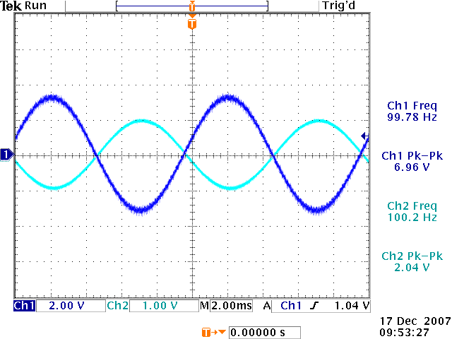
Figure 14. Input 2V Pk-Pk at 100Hz & Output 7V Pk-Pk at 100Hz (Without speaker load)

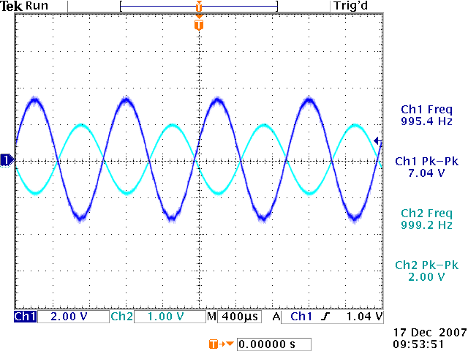
Figure 15. Input 2V Pk-Pk at 1kHz & Output 7.04V Pk-Pk at 1kHz (Without speaker load)

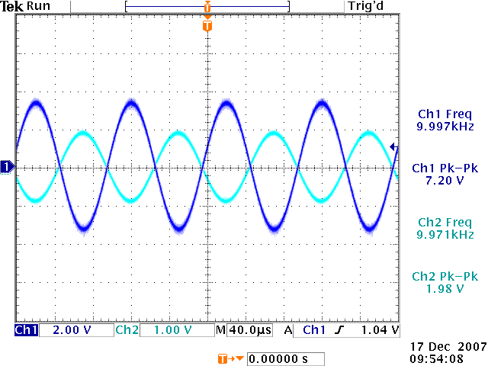
Figure 16. Input 2V Pk-Pk at 10kHz & Output 7.0V Pk-Pk at 10kHz (Without speaker load)

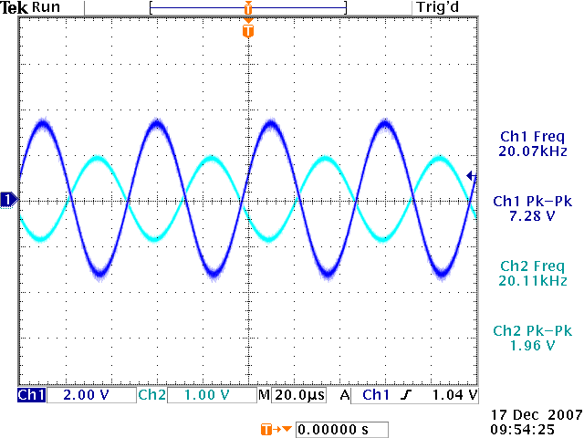
Figure 16. Input 2V Pk-Pk at 20kHz & Output 7.0V Pk-Pk at 20kHz (Without speaker load)

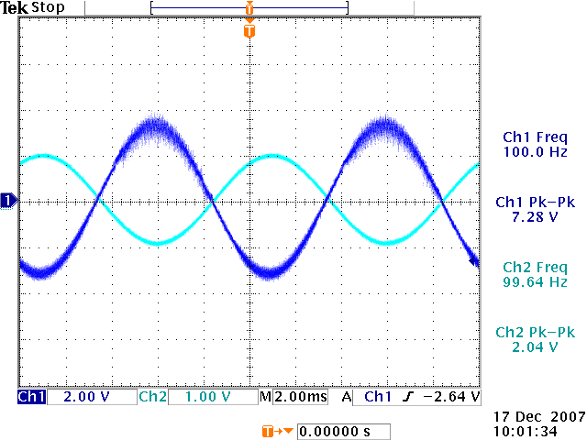
Figure 17. Input 2V Pk-Pk at 100Hz & Output 7.25V Pk-Pk at 100Hz (With speaker load)

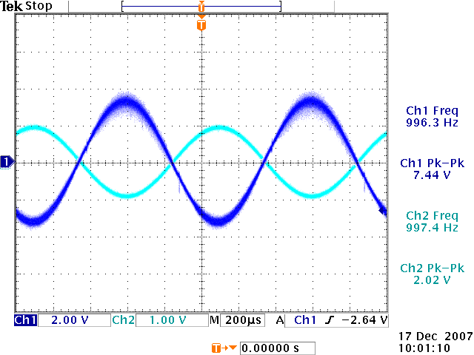
Figure 18. Input 2V Pk-Pk at 1kHz & Output 7.2V Pk-Pk at 1kHz (With speaker load)

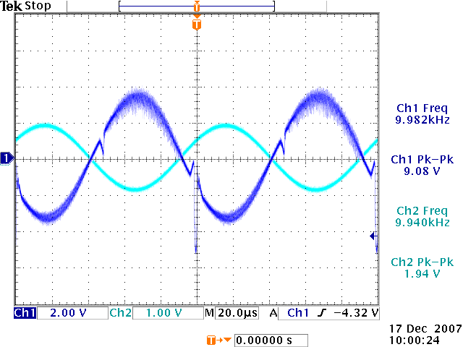
Figure 19. Input 2V Pk-Pk at 10kHz & Output 7.2V Pk-Pk at 10kHz (With speaker load)

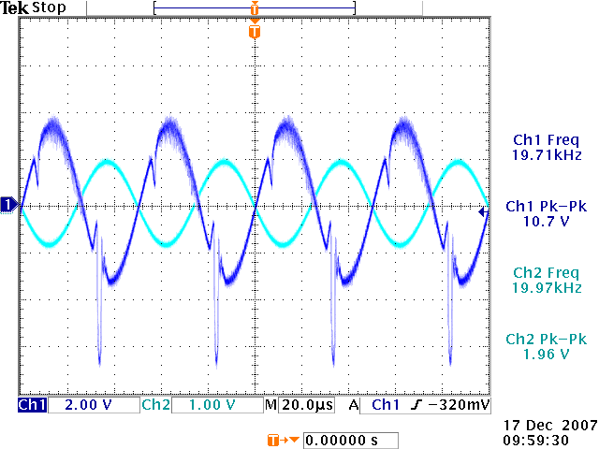
Figure 20. Input 2V Pk-Pk at 20kHz & Output 7.2V Pk-Pk at 20kHz (With speaker load)

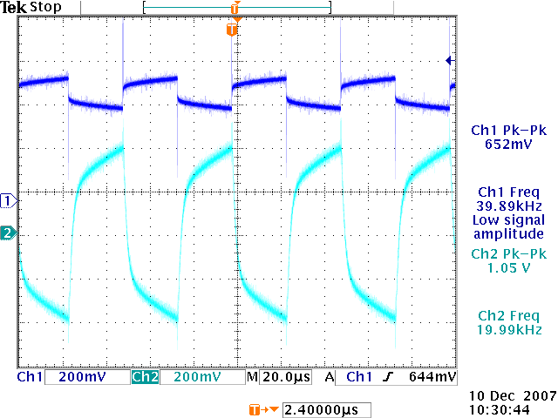
Figure 21. Square Wave Input 1V Pk-Pk at 20kHz & Output 0.8V Pk-Pk at 20kHz
(Without speaker load)

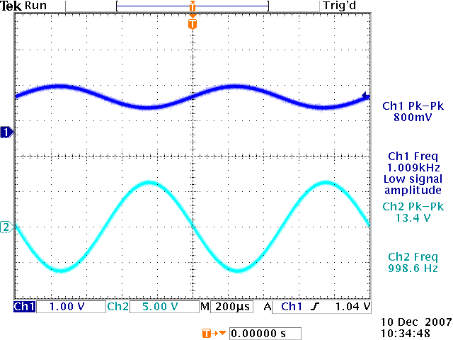
Figure 22. Maximum gain of 13.4V Pk-Pk with 0.8V Pk-Pk input at 1kHz
(Without speaker load)

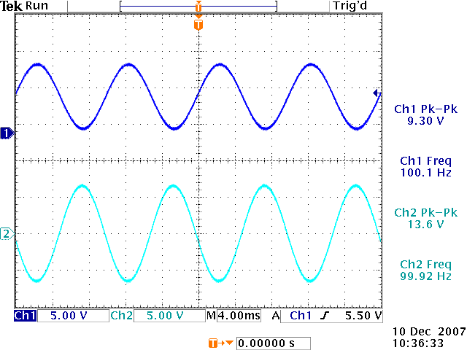
Figure 23. Maximum gain of 13.6V Pk-Pk with 10V Pk-Pk input at 100Hz
(Without speaker load)

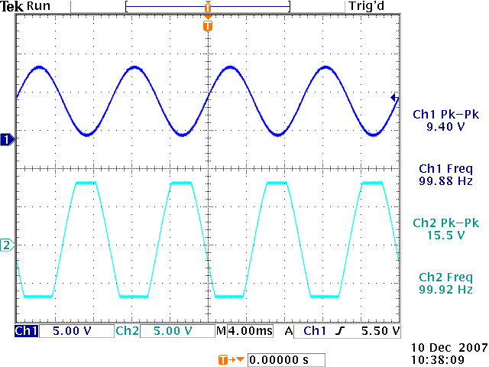
Figure 24. Output clipping with higher gain
(Without speaker load)

Measured DC Voltages
DC Voltages with 5V pk-pk input signal with 1kHz frequency

Input: 2.52V
Output : 0V
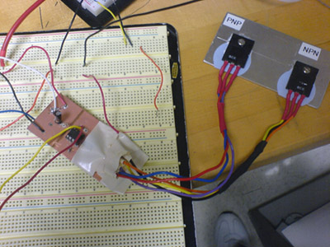
Figure 25. Picture of the final circuit with transistor pins covered up

- Conclusion
The objective of this circuit is to amplify the voice signal sent from FM and PWM circuits. This simple circuit is capable of producing 200Watts with higher input voltages. For the purpose of this project +/- 9V batteries are used so the maximum output power is limited to about 4.5 Watts. It was difficult to simulate the model of the speaker since I did not know the specific specs of the speaker available in the lab. The PSPICE simulation results heavily depended on the model of the speaker. The simulations done with the speaker model better correlated with the actual data. As seen in figure 12 the amplifier worked with constant gain up to 50 kHz, which was sufficient for our project. The final circuit is installed inside an aluminum box along with the FM, PWM and optical receiver circuits.
This circuit can be improved by adding a low pass filter to cut off the gain after 20kHz. This would save battery power. Also by adding a buffer stage so that the input won’t drop due to impedance mismatch. If I’m to redo this circuit I would do the above and make the lines on PCB board a little thicker. During this project faced an issue with the BJT’s pins. They kept breaking off the soldering due to the stress applied to them by the weight of the transistors. This could be prevented by using a socket to hold the pins in place.
The ENEE417 course taught me more than just circuit building techniques. It taught me valuable lessons in understand and identifying problems associated with circuits and how to apply what I truly know and understand to build new devices and/or to modify them.

- Cost
Cost for Parts
2 - LM741 op-amps | $0.30
1 - 1KΩ resistors | $0.01
1 - 50kΩ variable resistor | $1.30
1 - 20µF capacitor | $0.20
1 - 8Ω Speaker | $20.00
1 - MJL3281A NPN BJT | $3.50
1 - MJL1302A PNP BJT | $3.50
Total Cost | $28.81
Estimated man hours needed to design and build from scratch: 15 hours
Estimated man hours I would need: 4 hours
- Reference
[1] S. Sedra, and K. Smith, “Microelectronic circuits”, 5th ed. New York: Oxford University Press, 2004, pp.1240
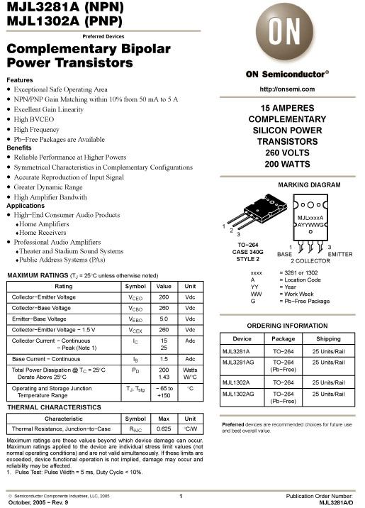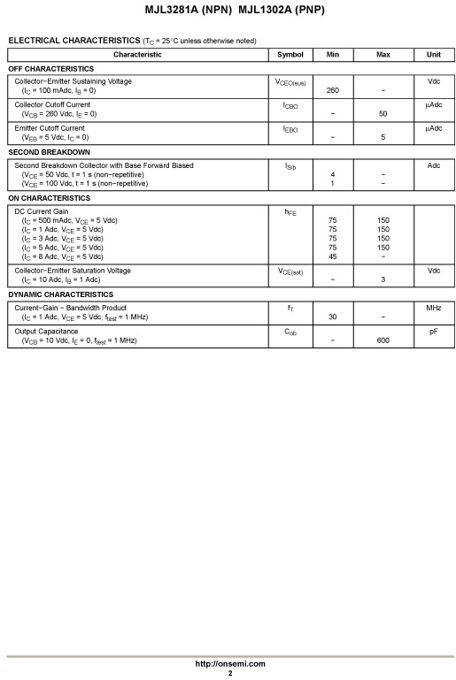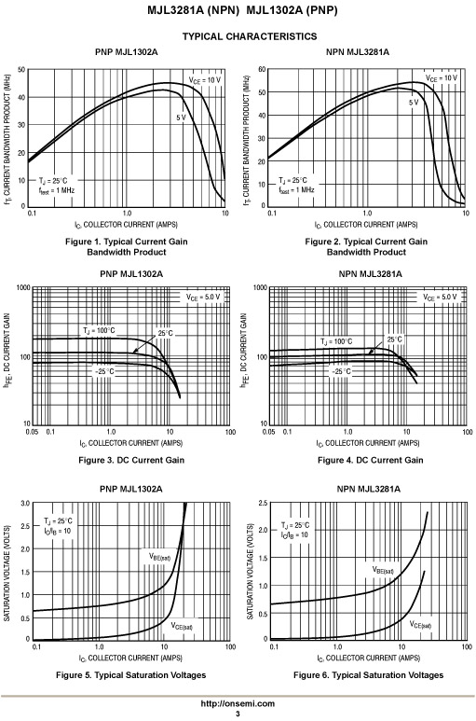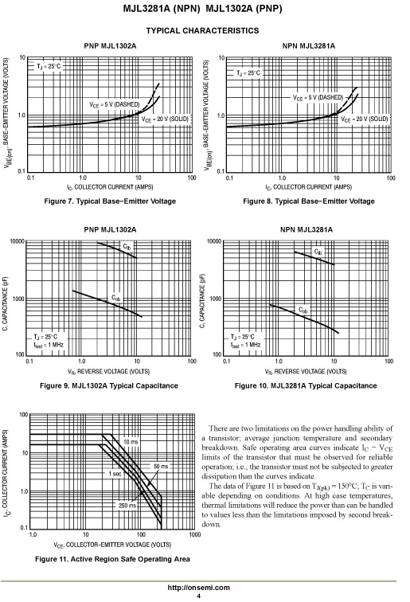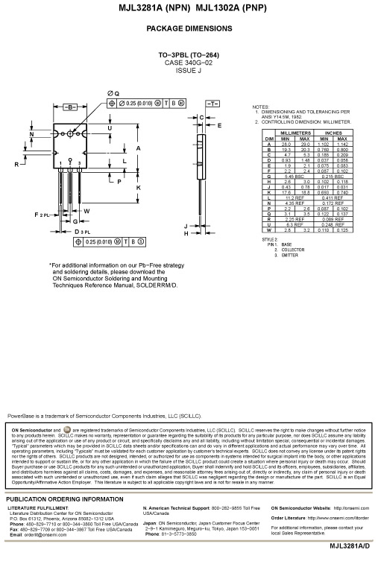
DATA SHEET FOR
MJL3281A & MJL1302A
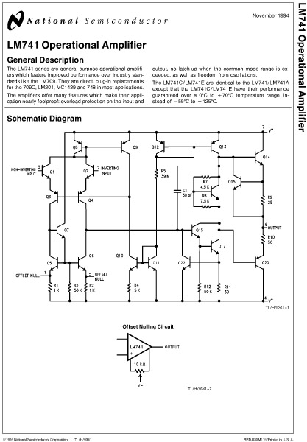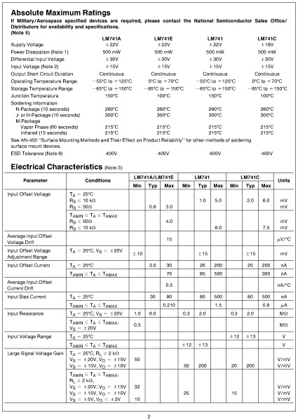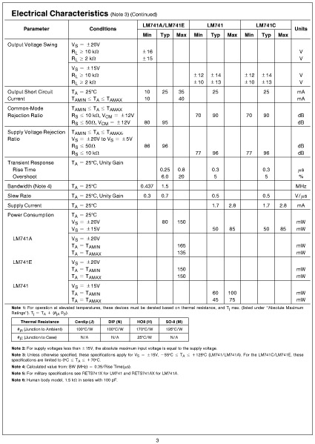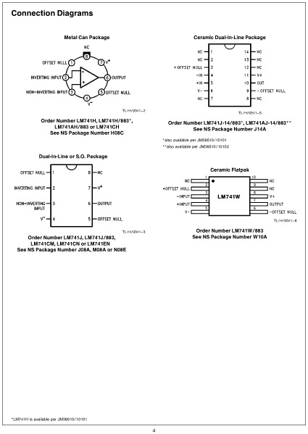
DATA SHEET FOR
LM741
December 17, 2007. This work was performed as a design project in ENEE417, Department of Electrical and Computer Engineering, University of Maryland, College Park, MD 20742 USA.

